***Artificial Intelligence***

Artificial intelligence is nothing but simulation of human intelligence, especially by machines and computer systems.

* It is done by:
  + Reasoning:
    - It can process about something and make a judgement.
    - Or process a logic.
  + Learning
    - It can learn from experience or processes.
    - For eg, chess AI
  + Problem solving
    - It can solve problem by doing computation and applying logic.
  + Perception
    - It can notice or percept about something that it processes.
    - For eg, Tesla car processes it environment while driving.

***State space search***

* It is a set of state from start to the goal.
* In these states answers to problems are meant to me solved.
* This search consist of, *states*, *action*, *result* and *cost*.
* It is done to achieve goal.
* Here problems are *precisely* present so that it can *analyzed* efficiently.

***Uninformed Search***

* Search without information.
* Also known as Blind search algorithm.
* Time complexity is more(time, space).
* No knowledge of path.
* Time consuming.
* DFS, BFS, etc.

***Informed Search***

* Searches with information.
* Time complexity is less.
* We have knowledge of path.
* Quick solution.
* Uses *heuristic*(as we know information).
* A*, Heuristics DFS, Best first search, etc.

***Breadth First Search(BFS)***

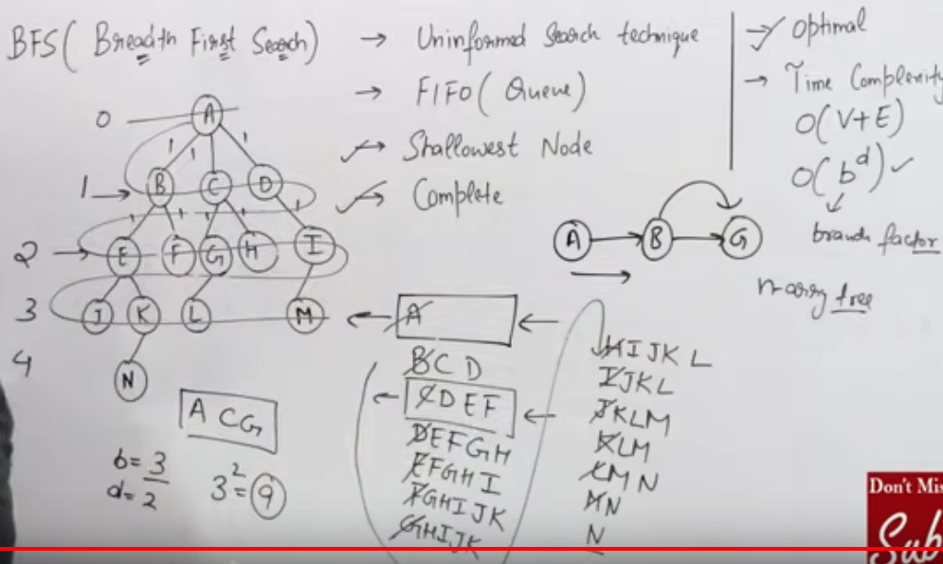

* Uninformed search technique.
* Queue(FIFO)
* Shallow nodes
* Complete
* Optimal
* Time complexity
  + DS: O(V+E), V=no. of nodes, E=no. of edges
  + AI: O(bd), b=branch factor, d=depth

***Depth First Search(DFS)***

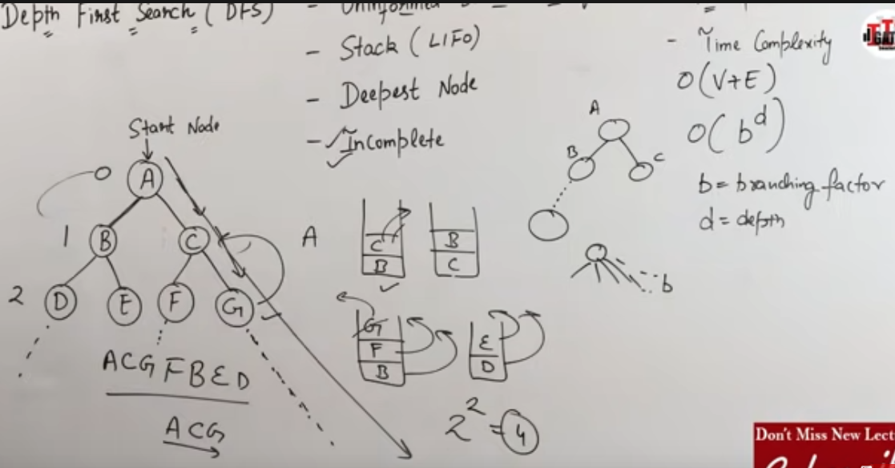

* Uninformed seach technique.
* Stack(LIFO)
* Deepest node
* Solution can be incomplete(as a branch can be infinity)
* Non-optimal
* Time complexity
  + DS: O(V+E), V=no. of nodes, E=no. of edges
  + AI: O(bd), b=branch factor, d=depth

***Bidirectional Search***

* It’s a simultaneous search.
* One search is from starting to goal.
* Another search is backward from goal to start.
* It stops when they meet.
* In BFS, search will be complete.
* In DFS, search may or may not be complete.
* Time complexity:
  + O[2(bb)]

***8-Puzzle Problem***

***Solving without Heuristic***

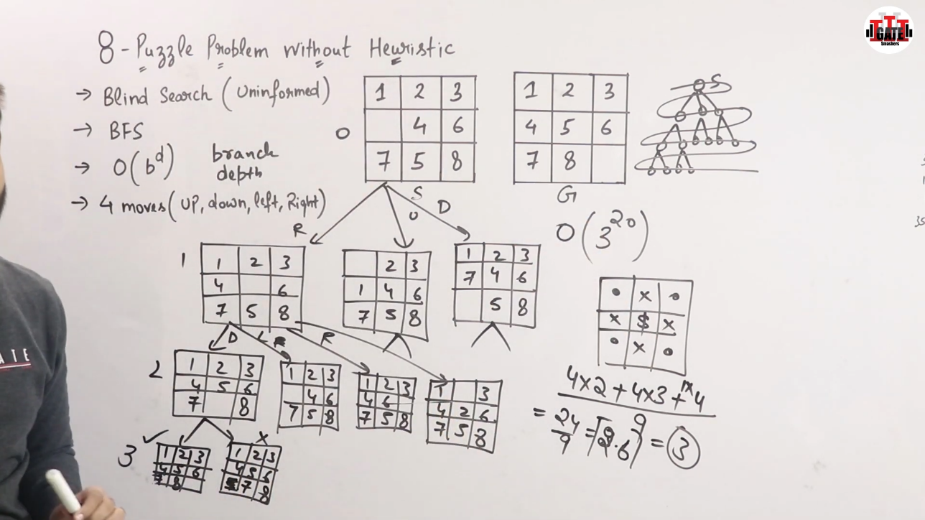

* Problem solved bu using Blind search(uninformed)
* Breadth first search.
* Will give optimal solution.
* Time complexity:
  + O(bd) ie, O(320)
* Blank part can move 4 moves.

***Solving with heuristic***

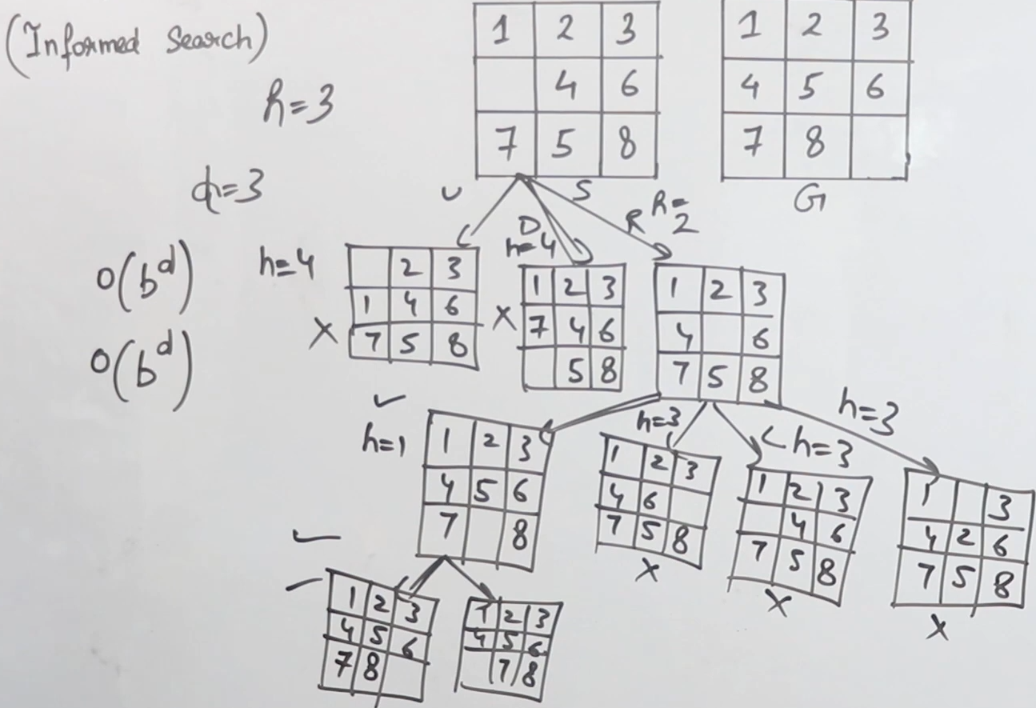

* Problem solved using Informed search obviously.
* Solution,
  + S1: We compare start and goal blocks.
  + S2: Calculate ‘h’ (No. of misplaced tiles).
  + S3: We move blank tile, where h is smallest.
  + S4: Step 2 and 3 will repeat till start block will be same as goal block.
* Time complexity:
  + O(bd)
  + Problem converted from non-polynomial(NM) to polynomial
* Soln may not be optimal but it’ll be good.

***Heuristic***

* Simple meaning ‘*Anuman lagana*’.
* Technique to solve a problem quickly.
* And efficiently.
* Soln may not be optimal but it’ll be good.
* It reduces problem
  + Euclidean distance
    - By calculating distance
      * √[(x2-x1)2 + (y2-y1)2]
  + Manhattan distance
    - Sum of the absolute differences of their points/coordinates.

***Test and Generate (Informed search/ Heuristic search/ DFS with Backtracking)***

* Generates a possible soln.
* Test if soln is actual goal.
* If YES
  + Quit
* Else
  + Repeat above steps till we get actual goal.
* If heuristics is good time complexity will be good.

**Properties:**

* Informed.
* Non-redundant.
* Complete.

***Best First Search***

* Informed search
* Uses heuristic

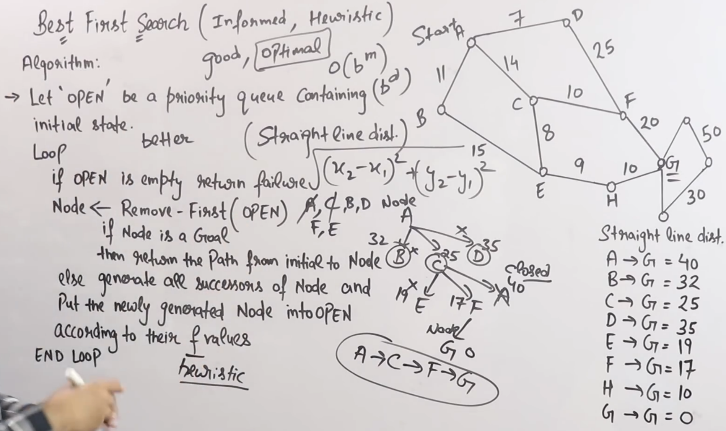

* It already has costs(as informed data, written in no.).
* It chooses best heuristic to travel from start to goal.
  + In above it’s A->C->F->G
* It gives good or optimal soln.
* Time complexity:
  + O(bm) or O(bd)
  + In average or best case
    - It’s better than Uninformed search

***Beam Search Algorithm***

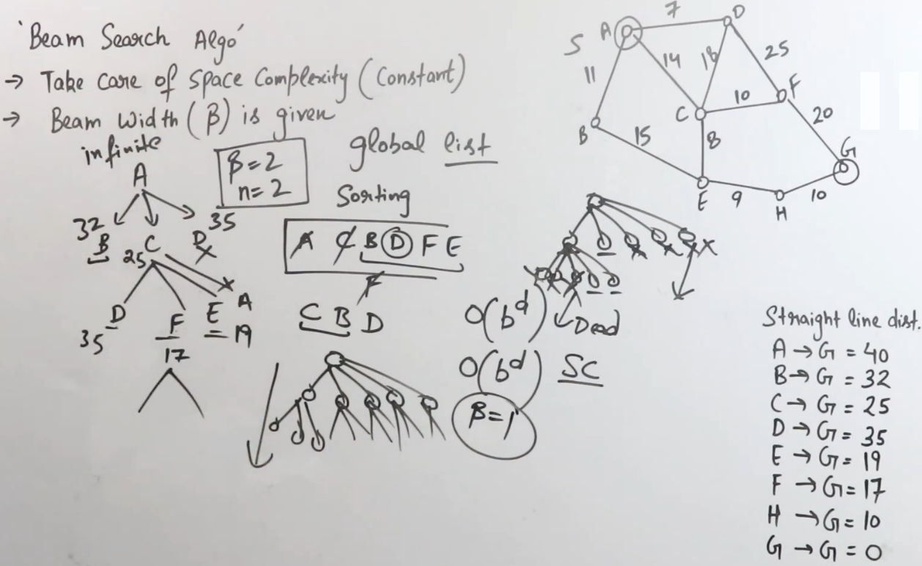

* Based on heuristic
* Takes care of space complexity(constant)
* Beam width(n) is given or we have to find
* Here,
  + A queue is sorted
  + Takes few node let’s take n=2,
  + And removes all nodes except best 2 which is taken above.
  + More than 1 beam/node is taken if,
    - Node we are working on might go dead end
  + If beam is only 1, it’s Hill climb algo.
* Time complexity:
  + O(bd)

***Hill Climbing Algorithm***

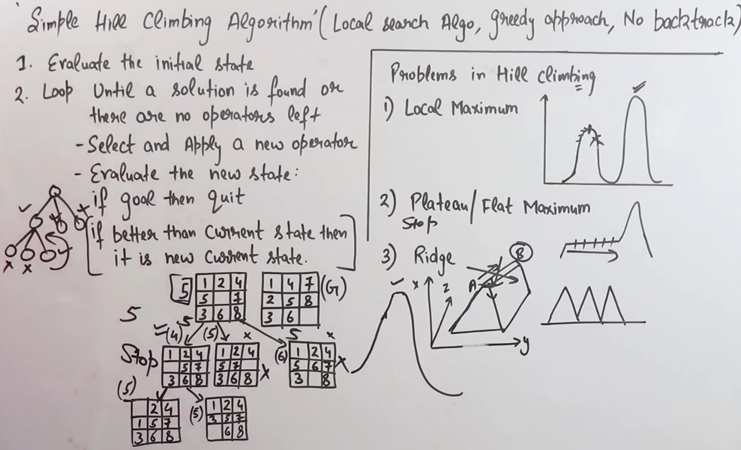

* It’s done on greedy approach.
* It can’t use backtracking
  + As beam is 1
* It moves ahead on node
  + Choosing best node
  + Removing space of all other nodes.
  + There can a better soln
    - But we can’t backtrack, as it removes all nodes.
  + It any node is better than current node than it is new node.
* Examples,
  + Local maximum
  + Plateau/Flat maximum
  + Ridge

***A* Algorithm***

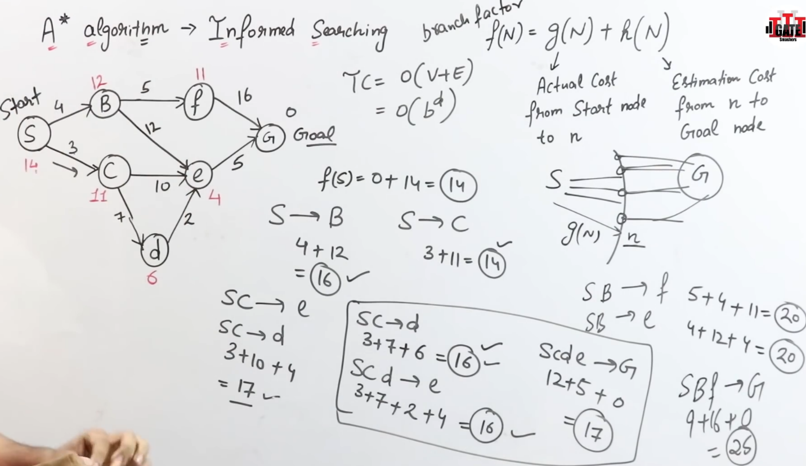

* An algorithm to find shortest path from start to goal state.
* Cost, f(n) = g(n) + h(n)
* Time complexity:
  + O(v+E)
  + O(bd)

*How to make A* admissable?*

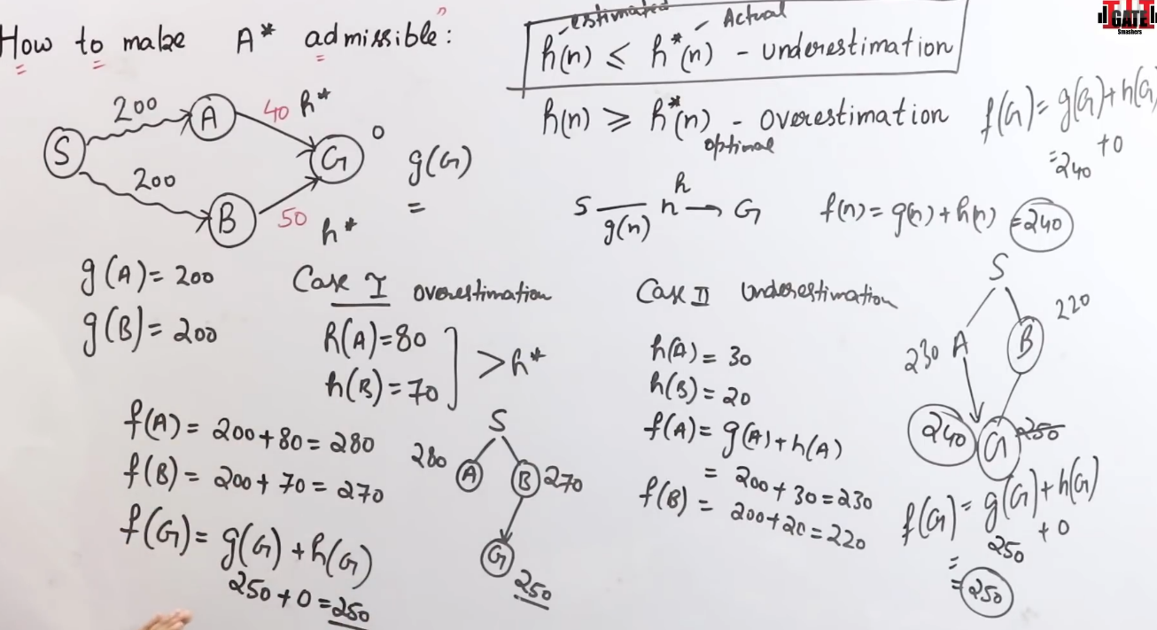

***AO* Algorithm (And/Or)***

* Problem decomposition
* This algo, doesn’t explore other paths if it finds a soln.
* 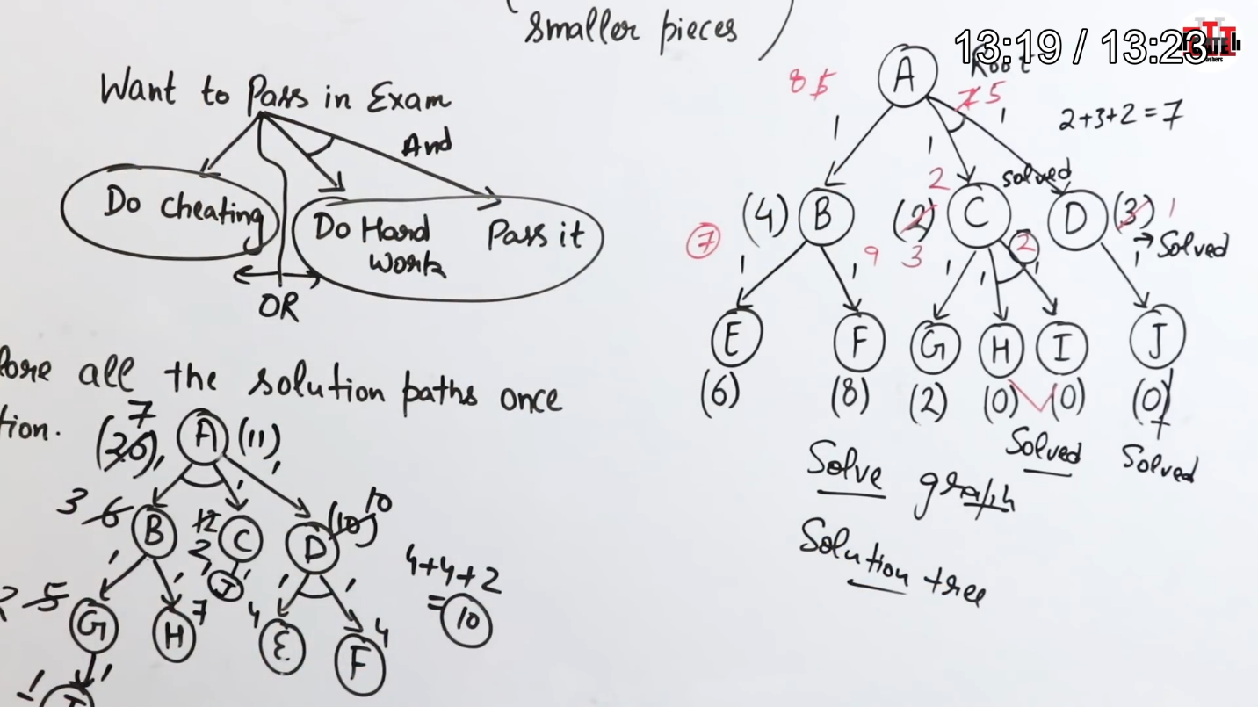

***Introduction to Game Playing***

* An important domain of AI.
* Games don’t require much knowledge.
* And the games must not be luck based.
* The only knowledge we need to provide is the rules, legal moves and the conditions of winning or losing the game.
* And The no. of moves.

***Minimax Algorithm***

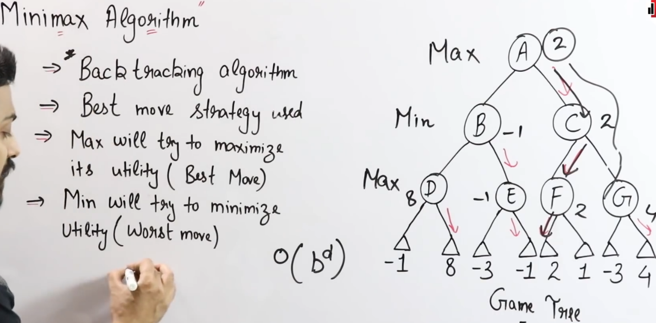

* Backtracking algo
* Best moves strategy
* Max will find best moves
* Min will find worst moves
* Time complexity:
  + O(bd)
* Not for big tree games like chess.
* It can be used in tic tac toe.

***Alpha-Beta Pruning***

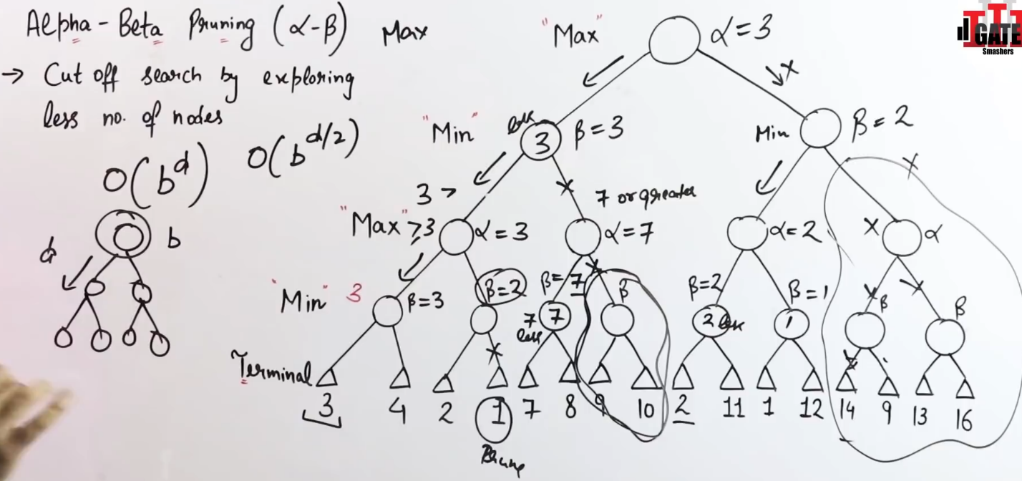

* Advanced version of Minimax Algo.
* Alpha is max while beta is min.
* It prunes or removes less beta nodes.
* Here, nodes with greater beta value is chosen.

***Knowledge representation and Reasoning***

* Knowledge is the information, understanding and skills anything that is gained through experience.
* Reasoning means applying logic on knowledge.
* Terminologies:
  + Logic:
    - Propositional logic
    - Predicate logic
  + Rules:
    - If else
  + Sementic net:
    - Sementic means meaning.
    - Ex, Google graph
  + Frames:
    - Slotes and fillers
  + Script:
    - It’s the script we give to agents to do things.

***Propositional Logic***

* Logic on statement.
* Either true or false, not both.
* Syntax:
  + Simple
    - eg, 1+1=true
  + Complex
    - Not simple

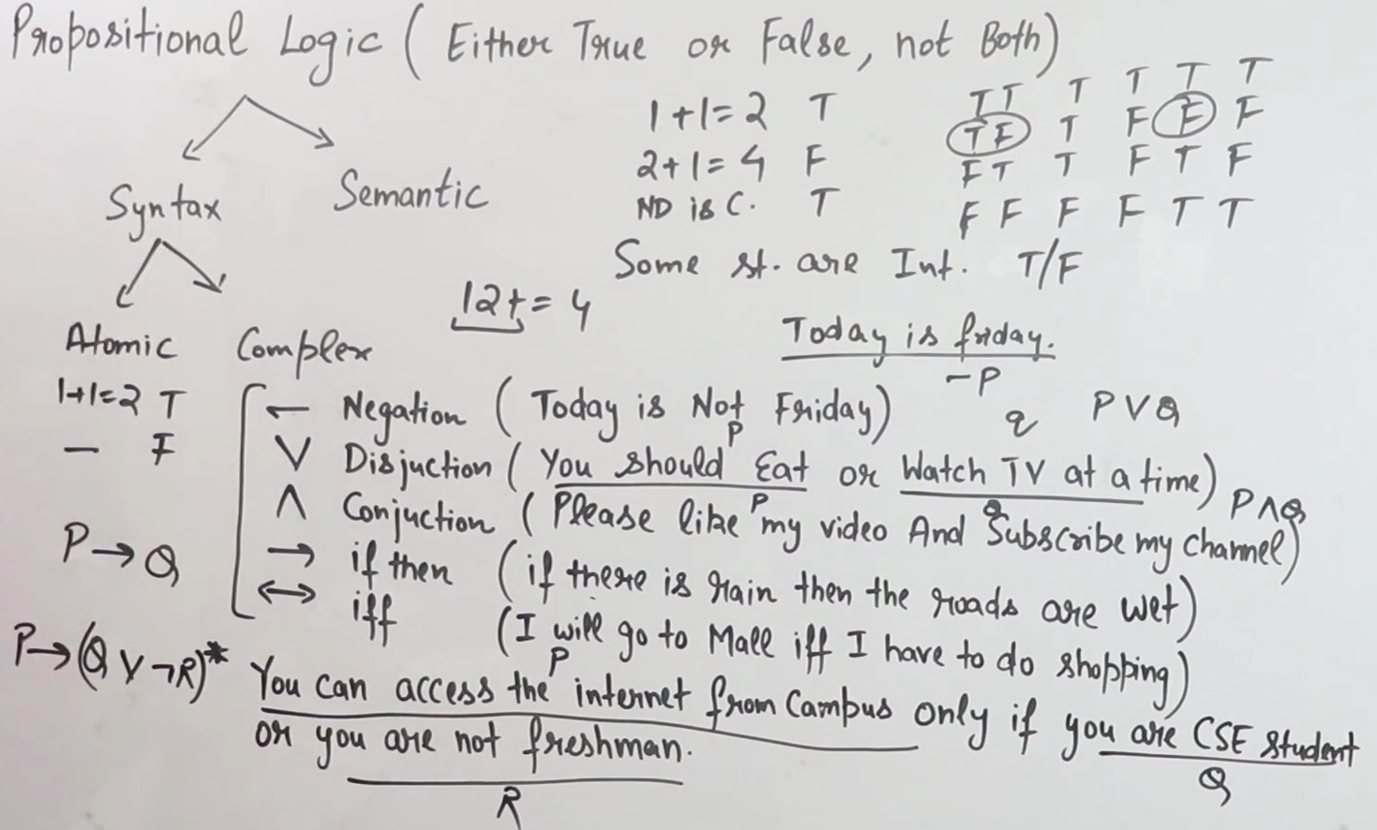

***Agents/ Intelligent Agents***

* Agents:
  + ***Perceives*** from ***environment***.
  + Makes ***decision***.
  + Then, does ***actions***.
  + Provides ***performance*** of agent.
* Designed on PEAS:
  + Performance.
  + Environment.
  + Actions.
  + Sensors(perception).
* Main goal:
  + High performance.
  + Optimised results.
  + Rational actions.

***Types of agents:***

1. Simple reflex agent
   1. Acts on basis of current perception.
   2. Ignores rest of percept history.
   3. Based on If-then.
   4. Works on fully observable environment.
   5. Environment -> percept(sensor) ->current situation ->if then(condition) -> action
   6. *Turant* action.
2. Model based reflex agent
   1. It is model based (i.e, Knowledge based)
   2. Has some percept history and works on it.
   3. Works on partially observable environment.
3. Goal based agent
   1. Based on model based reflex agent.
   2. Works on current and past history perception.
   3. We know Initial and goal state. Ie, we know goal.
   4. Works on searching and planning.
4. Utility based agent
   1. Focus on utility and not goal.
   2. Works on utility function.ie,
      1. After completing current state.
      2. It reaches next state.
      3. It determines this state is happy or not happy.
   3. Deals with happy and not happy states.
      1. It determines by comparing current states with past states.
   4. Works on partially observable environment.
5. Learning agent

***Fuzzy Logic***

* Father of fuzzy logic, Lotfi Zadeh.
* Superset of boolian logic.
  + Gives flexiblity.
* Represent uncertainty.
* Represent with degree.

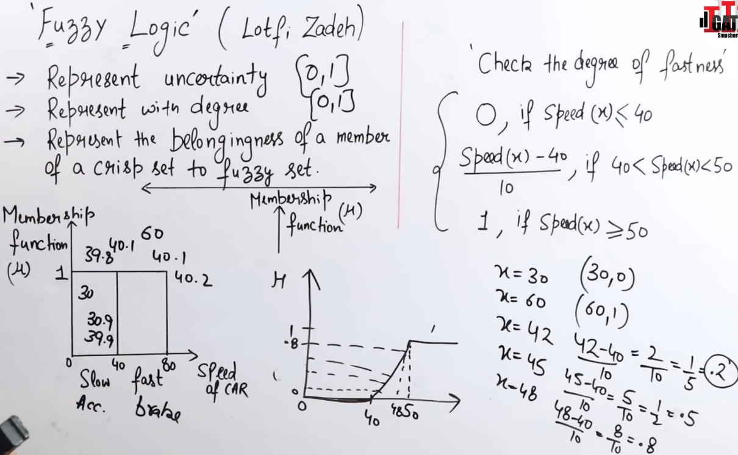

* For eg,
  + If speed<40, accelarate
  + Else, apply break.
  + But, if speed is 41 we apply break then suddenly its speed is 39 and we accelarate.
  + Then, this loop will repeat.
  + To stop this we use fuzzy logic, it gives flexiblity.
* Operations:

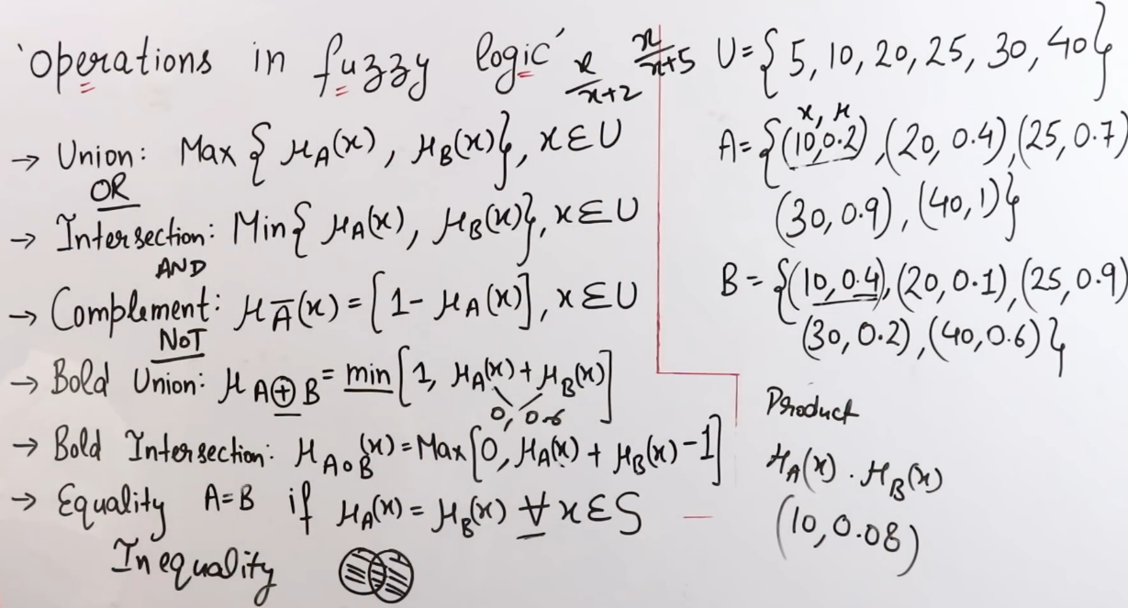

***Neural Networks***

* A computing system made up of a number of simple, highly interconnected processing elements, which process information by their dynamic state response to external inputs.
* ANNs are composed of multiple **nodes**, which imitate biological **neurons** of human brain.
* The neurons are connected by links and they interact with each other.
* The nodes can take input data and perform simple operations on the data.

***Natural Language Processing(NLP)***

* Computer replicating how human process communication.
* **Applications**:
  + Speech Recognition(google assistant)
* Sentimental Analysis
  + Sentimental analysed in twitter.
* Machine Translation
* Chat bot, etc.
* Speech recognition -> Natural language understanding(NLU) -> Natural language generation(NLG) -> O/P
  + NLU:
    - What user is saying?
    - Intent
    - Meaning
    - **Challenges**:
      * Lexical ambiguity
        + All words divided
        + Words can have different meaning
      * Syntactic ambiguity
        + Structure of sentence
      * Sementic ambiguity
        + Meaning
      * Pragmatic ambiguity
        + Context
  + NLG:
    - What should we say to user?
    - Intelligent and conversational.
    - Deal with structured data.
    - Text and sentence planning.

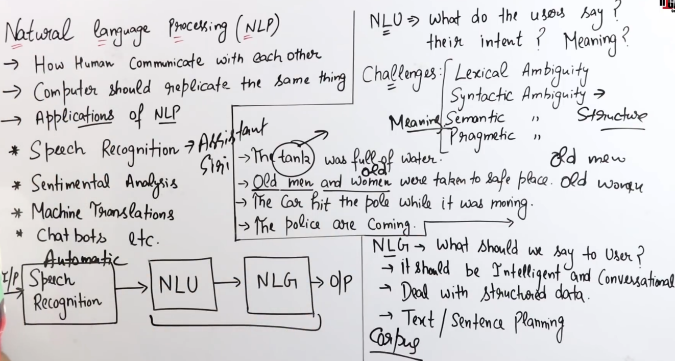

***Various types of Leanings or Machine Learning in AI:***

1. *Supervised Learning*
   1. Data is trained
   2. Have both i/p and o/p
   3. Classification
   4. Eg,
      1. Naire Bayes Algo.
2. *Unsupervised Learning*
   1. Only i/p
   2. Clustering
      1. Grouping inputs
   3. Eg,
      1. K-mean
3. *Reinforcement Learning*
   1. Works on reward/penalty
   2. Agents gets reward or penalty for its action
   3. Eg,
      1. Q-Learning

***Genetic Algorithm***

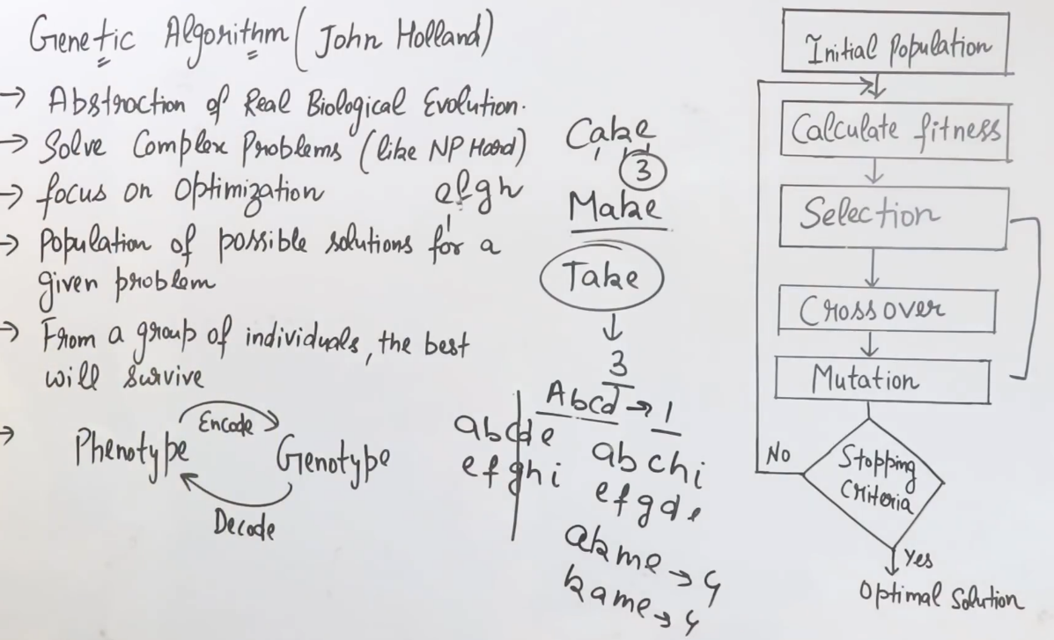

* Phenotype:
  + Input in raw format
* Genotype:
  + Input encoded for us to understand.

***Constraint satisfaction Algorithm:***

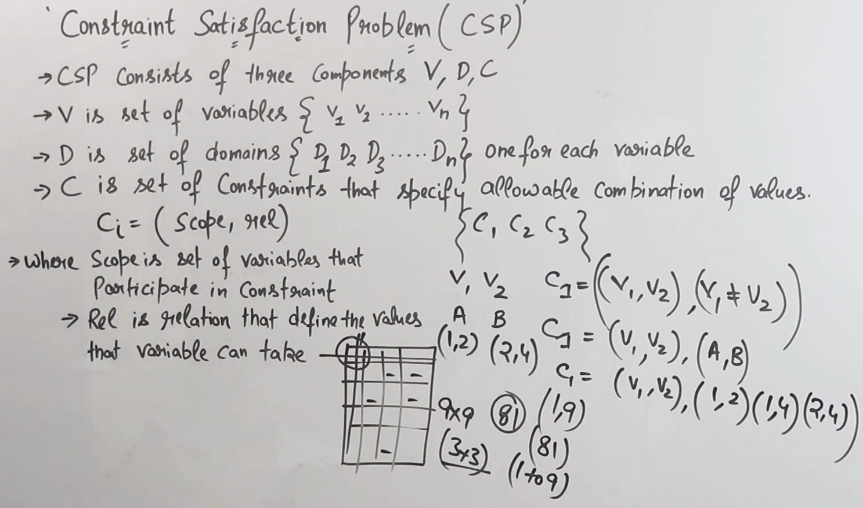

***Constraint satisfaction Problem:***

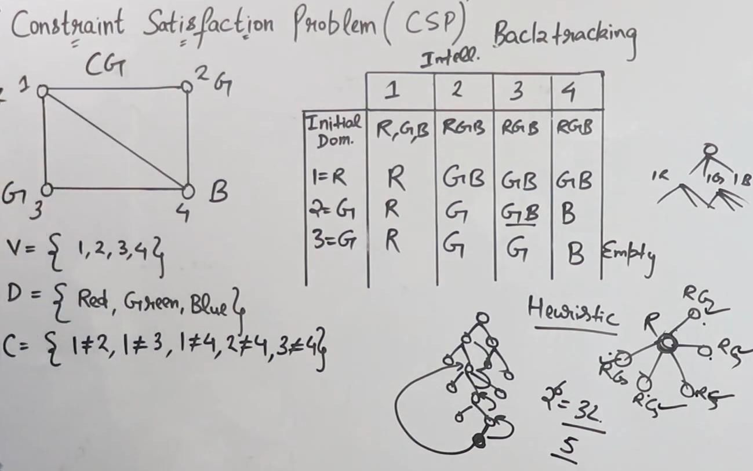

=================================END==============================